Decorator

UML class diagram

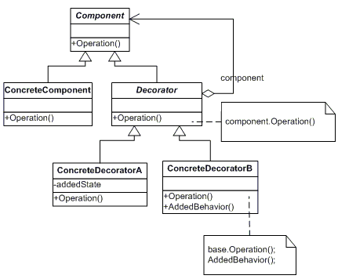

Participants

The classes and objects participating in this pattern are:
- Component (LibraryItem)
  - defines the interface for objects that can have responsibilities added to them dynamically.
- ConcreteComponent (Book, Video)
  - defines an object to which additional responsibilities can be attached.
- Decorator (Decorator)
  - maintains a reference to a Component object and defines an interface that conforms to Component's interface.
- ConcreteDecorator (Borrowable)
  - adds responsibilities to the component.

Strategy

UML class diagram

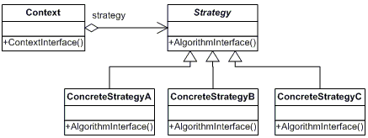

Participants

The classes and objects participating in this pattern are:
- Strategy (SortStrategy)
  - declares an interface common to all supported algorithms. Context uses this interface to call the algorithm defined by a ConcreteStrategy
- ConcreteStrategy (QuickSort, ShellSort, MergeSort)
  - implements the algorithm using the Strategy interface
- Context (SortedList)
  - is configured with a ConcreteStrategy object
  - maintains a reference to a Strategy object
  - may define an interface that lets Strategy access its data.

Observer

UML class diagram

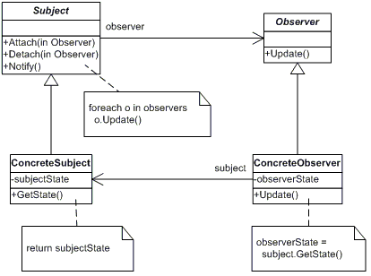

Participants

The classes and objects participating in this pattern are:
- Subject (Stock)
  - knows its observers. Any number of Observer objects may observe a subject
  - provides an interface for attaching and detaching Observer objects.
- ConcreteSubject (IBM)
  - stores state of interest to ConcreteObserver
  - sends a notification to its observers when its state changes
- Observer (IInvestor)
  - defines an updating interface for objects that should be notified of changes in a subject.
- ConcreteObserver (Investor)
  - maintains a reference to a ConcreteSubject object
  - stores state that should stay consistent with the subject's
  - implements the Observer updating interface to keep its state consistent with the subject's

Template

UML class diagram

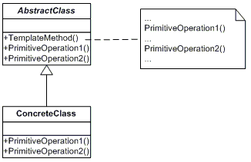

Participants

The classes and objects participating in this pattern are:
- AbstractClass (DataObject)
  - defines abstract primitive operations that concrete subclasses define to implement steps of an algorithm
  - implements a template method defining the skeleton of an algorithm. The template method calls primitive operations as well as operations defined in AbstractClass or those of other objects.
- ConcreteClass (CustomerDataObject)
  - implements the primitive operations ot carry out subclass-specific steps of the algorithm

State

UML class diagram

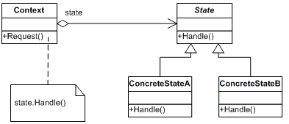

Participants

The classes and objects participating in this pattern are:
- Context (Account)
  - defines the interface of interest to clients
  - maintains an instance of a ConcreteState subclass that defines the current state.
- State (State)
  - defines an interface for encapsulating the behavior associated with a particular state of the Context.
- Concrete State (RedState, SilverState, GoldState)
  - each subclass implements a behavior associated with a state of Context

Command

UML class diagram

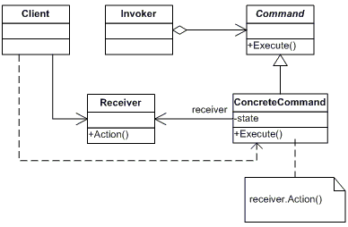

Participants

The classes and objects participating in this pattern are:
- Command (Command)
  - declares an interface for executing an operation
- ConcreteCommand (CalculatorCommand)
  - defines a binding between a Receiver object and an action
  - implements Execute by invoking the corresponding operation(s) on Receiver
- Client (CommandApp)
  - creates a ConcreteCommand object and sets its receiver
- Invoker (User)
  - asks the command to carry out the request
- Receiver (Calculator)
  - knows how to perform the operations associated with carrying out the request.

Factory

UML class diagram

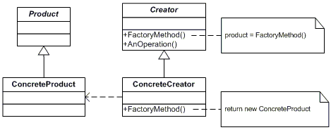

Participants

The classes and objects participating in this pattern are:
- Product (Page)
  - defines the interface of objects the factory method creates
- ConcreteProduct (SkillsPage, EducationPage, ExperiencePage)
  - implements the Product interface
- Creator (Document)
  - declares the factory method, which returns an object of type Product. Creator may also define a default implementation of the factory method that returns a default ConcreteProduct object.
  - may call the factory method to create a Product object.
- ConcreteCreator (Report, Resume)
  - overrides the factory method to return an instance of a ConcreteProduct.

Abstract Factory

UML class diagram
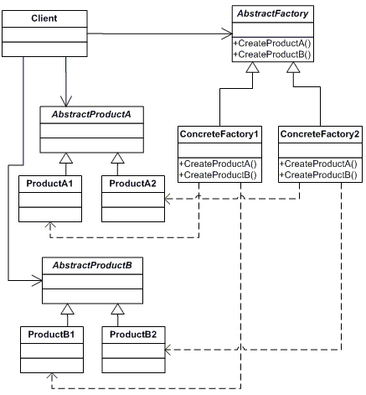

Participants

The classes and objects participating in this pattern are:
- AbstractFactory (ContinentFactory)
  - declares an interface for operations that create abstract products
- ConcreteFactory (AfricaFactory, AmericaFactory)
  - implements the operations to create concrete product objects
- AbstractProduct (Herbivore, Carnivore)
  - declares an interface for a type of product object
- Product (Wildebeest, Lion, Bison, Wolf)
  - defines a product object to be created by the corresponding concrete factory
  - implements the AbstractProduct interface
- Client (AnimalWorld)
  - uses interfaces declared by AbstractFactory and AbstractProduct classes

Composite

UML class diagram

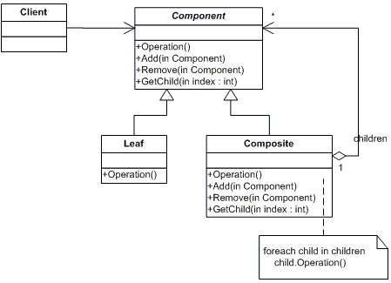

Participants

The classes and objects participating in this pattern are:
- Component (DrawingElement)
  - declares the interface for objects in the composition.
  - implements default behavior for the interface common to all classes, as appropriate.
  - declares an interface for accessing and managing its child components.
  - (optional) defines an interface for accessing a component's parent in the recursive structure, and implements it if that's appropriate.
- Leaf (PrimitiveElement)
  - represents leaf objects in the composition. A leaf has no children.
  - defines behavior for primitive objects in the composition.
- Composite (CompositeElement)
  - defines behavior for components having children.
  - stores child components.
  - implements child-related operations in the Component interface.
- Client (CompositeApp)
  - manipulates objects in the composition through the Component interface.

Facade

UML class diagram

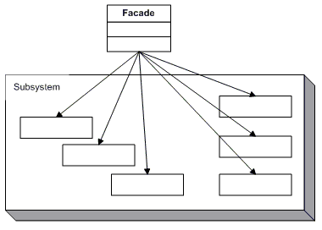

Participants

The classes and objects participating in this pattern are:
- Facade (MortgageApplication)
  - knows which subsystem classes are responsible for a request.
  - delegates client requests to appropriate subsystem objects.
- Subsystem classes (Bank, Credit, Loan)
  - implement subsystem functionality.
  - handle work assigned by the Facade object.
  - have no knowledge of the facade and keep no reference to it.

Iterator

UML class diagram

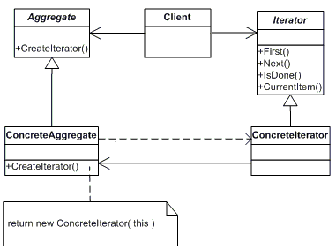

Participants

The classes and objects participating in this pattern are:
- Iterator (AbstractIterator)
  - defines an interface for accessing and traversing elements.
- ConcreteIterator (Iterator)
  - implements the Iterator interface.
  - keeps track of the current position in the traversal of the aggregate.
- Aggregate (AbstractCollection)
  - defines an interface for creating an Iterator object
- ConcreteAggregate (Collection)
  - implements the Iterator creation interface to return an instance of the proper ConcreteIterator

Template

UML class diagram

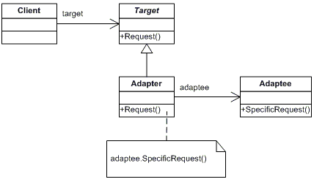

Participants

The classes and objects participating in this pattern are:
- Target (ChemicalCompound)
  - defines the domain-specific interface that Client uses.
- Adapter (Compound)
  - adapts the interface Adaptee to the Target interface.
- Adaptee (ChemicalDatabank)
  - defines an existing interface that needs adapting.
- Client (AdapterApp)
  - collaborates with objects conforming to the Target interface.

Singleton
UML class diagram

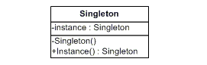

Participants

The classes and objects participating in this pattern are:
- Singleton (LoadBalancer)
  - defines an Instance operation that lets clients access its unique instance. Instance is a class operation.
  - responsible for creating and maintaining its own unique instance.

